Busy Bee Calendar – Detailed Technical Design Document

Design Class Diagram (DCD)
Refer to the attached diagram for the full system structure, including components, types, and relationships.
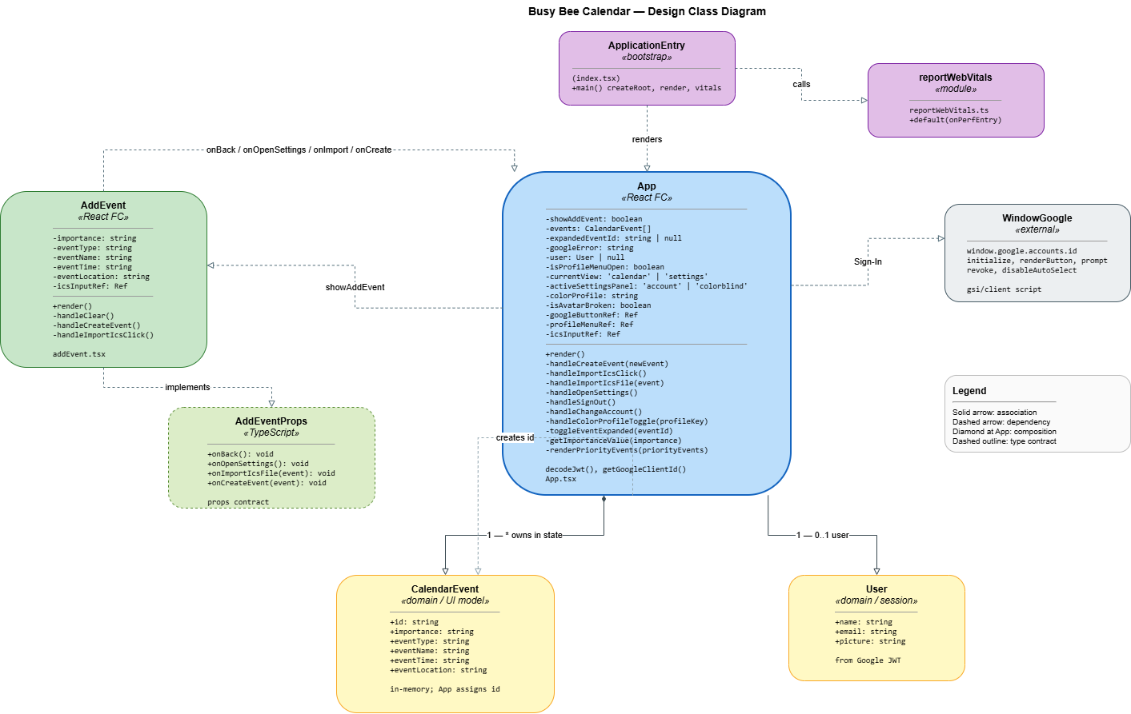
Link to Diagram

The Busy Bee Calendar app illustrates a clear architectural flow, starting from the ApplicationEntry (index.tsx), which bootstraps the system and renders the primary App component. This central React component acts as the orchestrator for the application's state, managing core data such as the list of calendar events, the currently authenticated user, and UI states like error messages or active settings panels. It also handles critical logic, including event creation, sign-out procedures, and priority-based event rendering.
The App component renders the AddEvent UI, which implements a specific AddEventProps contract to handle user interactions like clearing fields, creating new events, or importing files. To ensure secure access and a personalized experience, the system integrates with Windows Google (Google Identity Services) for OAuth-based sign-in, which populates the User domain model with the individual’s name, email, and profile picture.
On the data management side, the App component maintains a direct relationship with the CalendarEvent model, which serves as the primary data entity. Each CalendarEvent captures essential attributes such as event name, time, location, type, and an importance level that feeds into the system’s prioritization logic. By utilizing a combination of solid association lines for ownership and dashed dependency lines for functional calls, the Busy Bee Calendar uses a modular design where the user interface remains decoupled from the underlying domain data, allowing for easier updates and scalability.

Database Tables

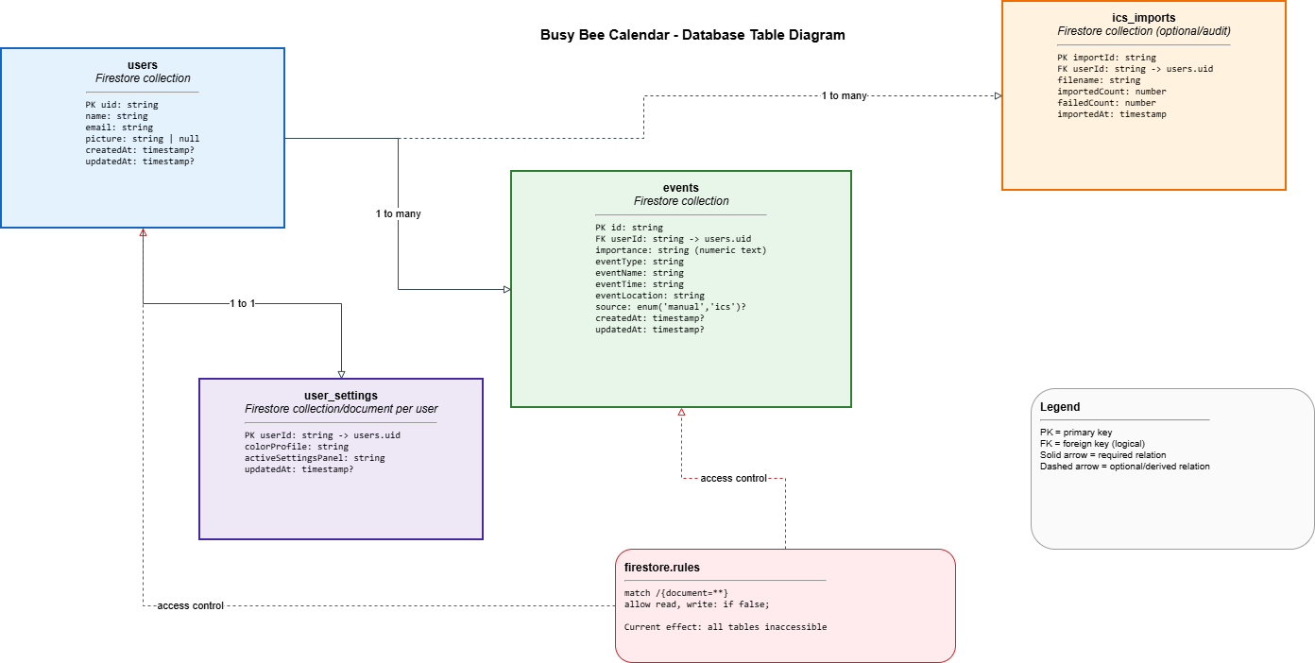
Link to Diagram

The state of the Busy Bee Calendar application is persisted within a Firestore database schema that serves as the interface between the server-side logic and the application data. This structure ensures that user preferences and calendar events are maintained across sessions. Several of the collections reference each other using unique identifiers; for instance, the events collection utilizes a user ID field to link specific tasks to the authenticated user who created them, ensuring data privacy and organization.

The database is structured into specialized collections—including users, user_settings, events, and ics_imports—to maintain a clean separation of concerns. This modular approach allows the system to scale effectively as new features are added, such as expanded event attributes or additional third-party integrations. The relationships between these entities, including the flow of data from the user profile to their categorized tasks, are illustrated in the diagram below.

Design Pattern: Strategy Pattern
Busy Bee Calendar uses the Strategy Pattern to handle event prioritization in a flexible and maintainable way. Instead of hardcoding priority logic directly into the main application or UI components, the system defines separate priority behaviors—highPriority, mediumPriority, and lowPriority—as interchangeable strategies. Each strategy encapsulates its own logic for determining how an event should be categorized and displayed. The Event model maintains a reference to a PriorityStrategy, which can be dynamically assigned or changed at runtime. This allows the application to determine an event’s priority category without modifying the underlying Event class or controller logic.
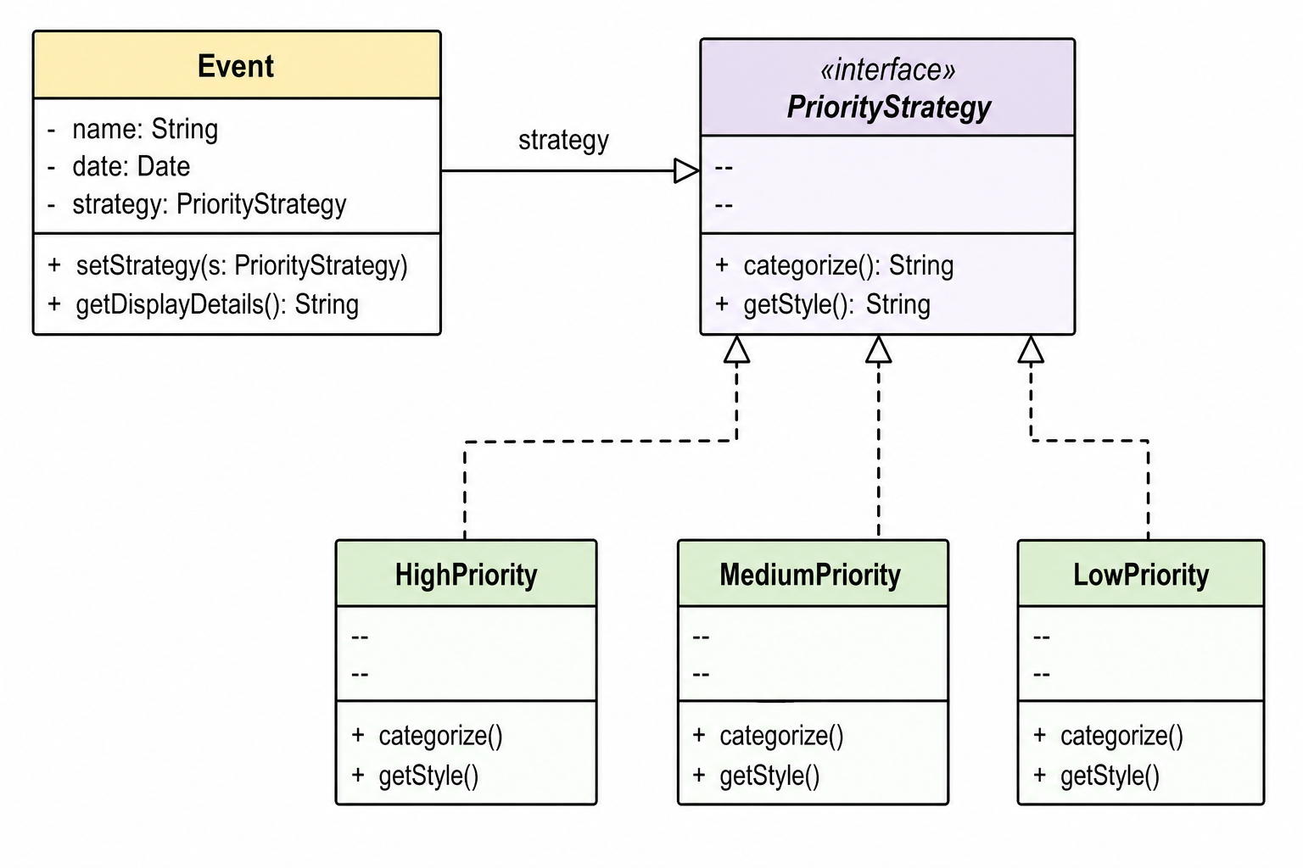
Link to Diagram

External Dependencies
- React
- TypeScript
- Google Identity Services (OAuth)
- Firebase

Team Responsibilities
- Project Planning & Coordination – Benjamin
  - Define project scope and milestones
  - Create and manage a timeline
  - Assign tasks and track progress
  - Facilitate team communication and meetings
  - Ensure deliverables are completed on time
- UI/UX Design – Jonathon
  - Design layout of the main dashboard and all screens (Add, Edit, Delete, Import)
  - Create task card visuals and priority color system
  - Ensure accessibility (color + numeric indicators)
  - Maintain visual consistency across the application
  - Provide design assets and mockups for implementation
- Application Logic Development – Jackson
  - Implement event data model (eventName, time, location, type, importance)
  - Develop event management functionality (add, edit, delete)
  - Implement the Strategy Pattern for priority handling
  - Handle data validation and business logic
  - Ensure proper interaction between the Model and the Controller
- Frontend Development & Integration – Marc
  - Build UI components using React and TypeScript
  - Implement Controller logic for handling user interactions
  - Connect UI to backend logic and data model
  - Integrate Google Identity Services (OAuth)
  - Manage navigation and screen transitions
- System Integration & Testing – Entire Team
  - Combine all components into a unified system
  - Perform testing (functional and usability)
  - Debug and fix issues
  - Ensure consistency between design and implementation
  - Prepare final deliverables and documentation

